Module 2

Jason Kremhelmer

Southern New Hampshire University

CS340: Client/Server development

Judy Mason

7/14/2024

**Verify your load** by “using” the “city” database, and issuing the following queries in the *mongo shell*:

1. db.inspections.find({"id" : "10021-2015-ENFO"})
2. db.inspections.find({"result":"Out of Business"},{"business_name":1}).limit(10)

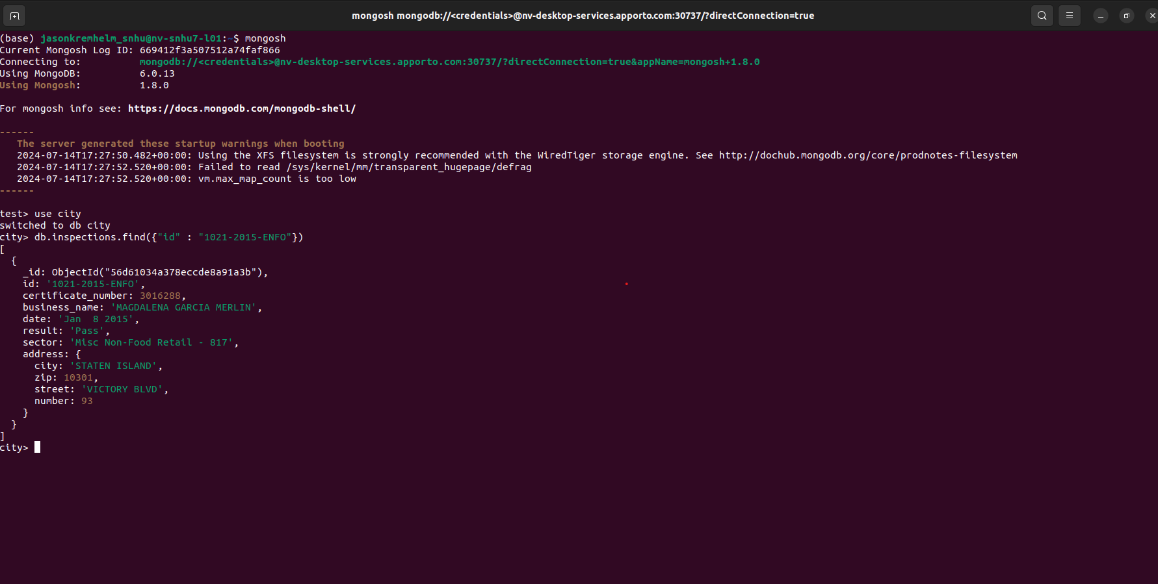

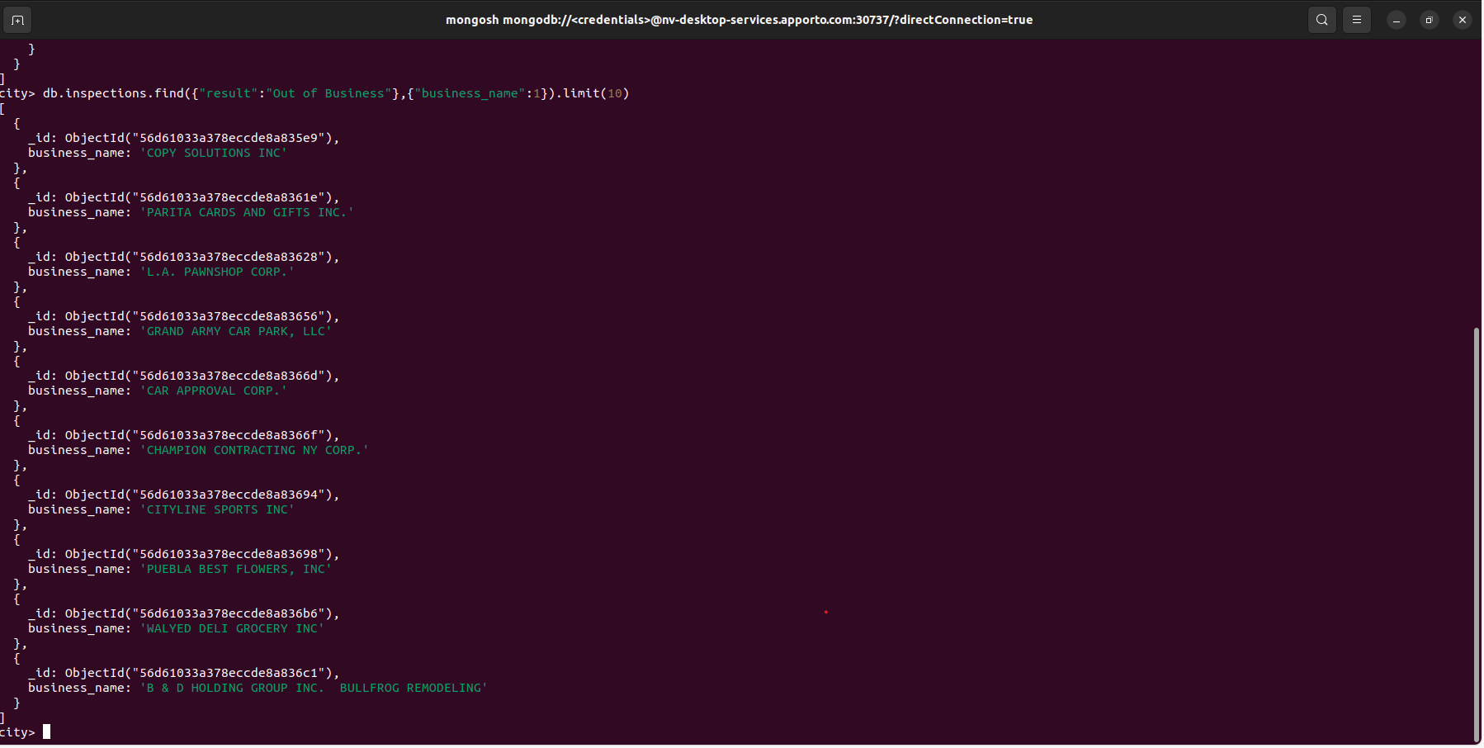

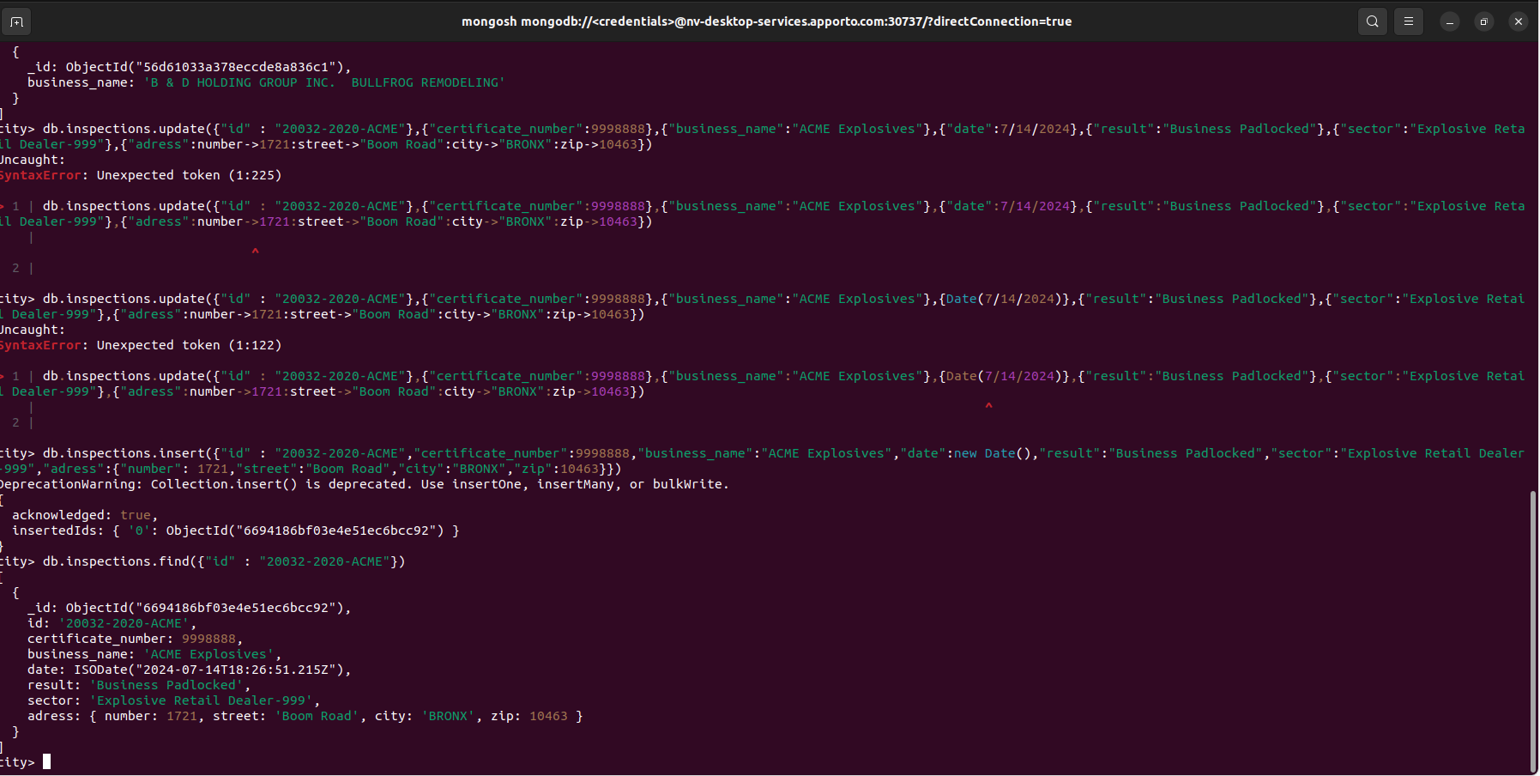Answer the following questions using **MongoDB queries**.

What is the distinct list of inspection “sector” in the current inspections collection? How many are in the list?

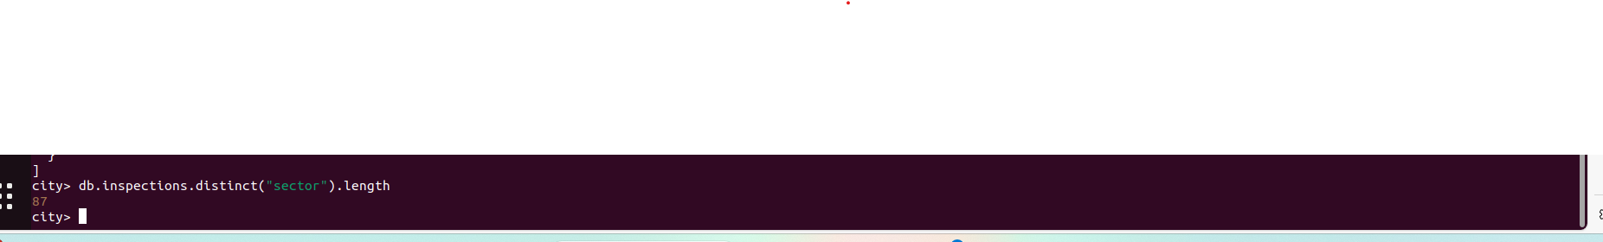

What is the difference in the date data type for the business named “AUSTIN 2012” versus your business document insertion of “Acme Explosives”?

The difference is the way the date is entered. In the Austin example, the date is entered manually, while in the ACME one, we used date().

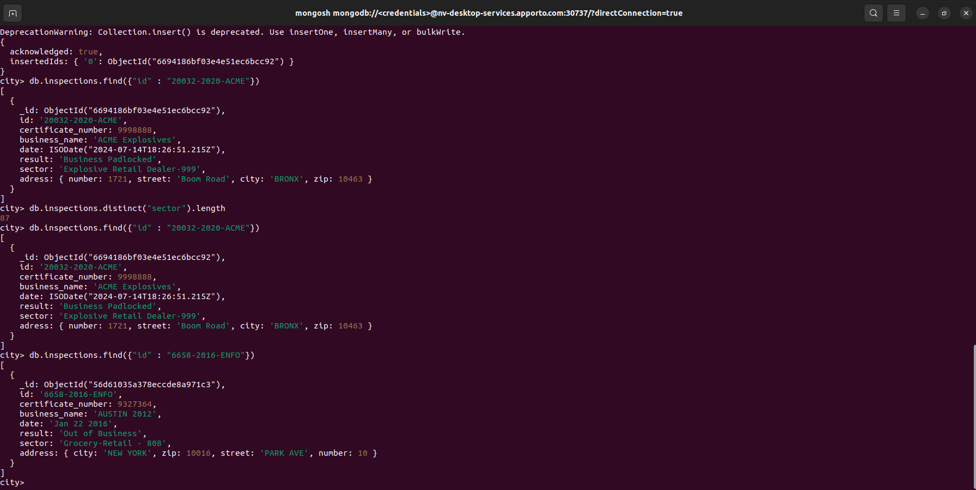

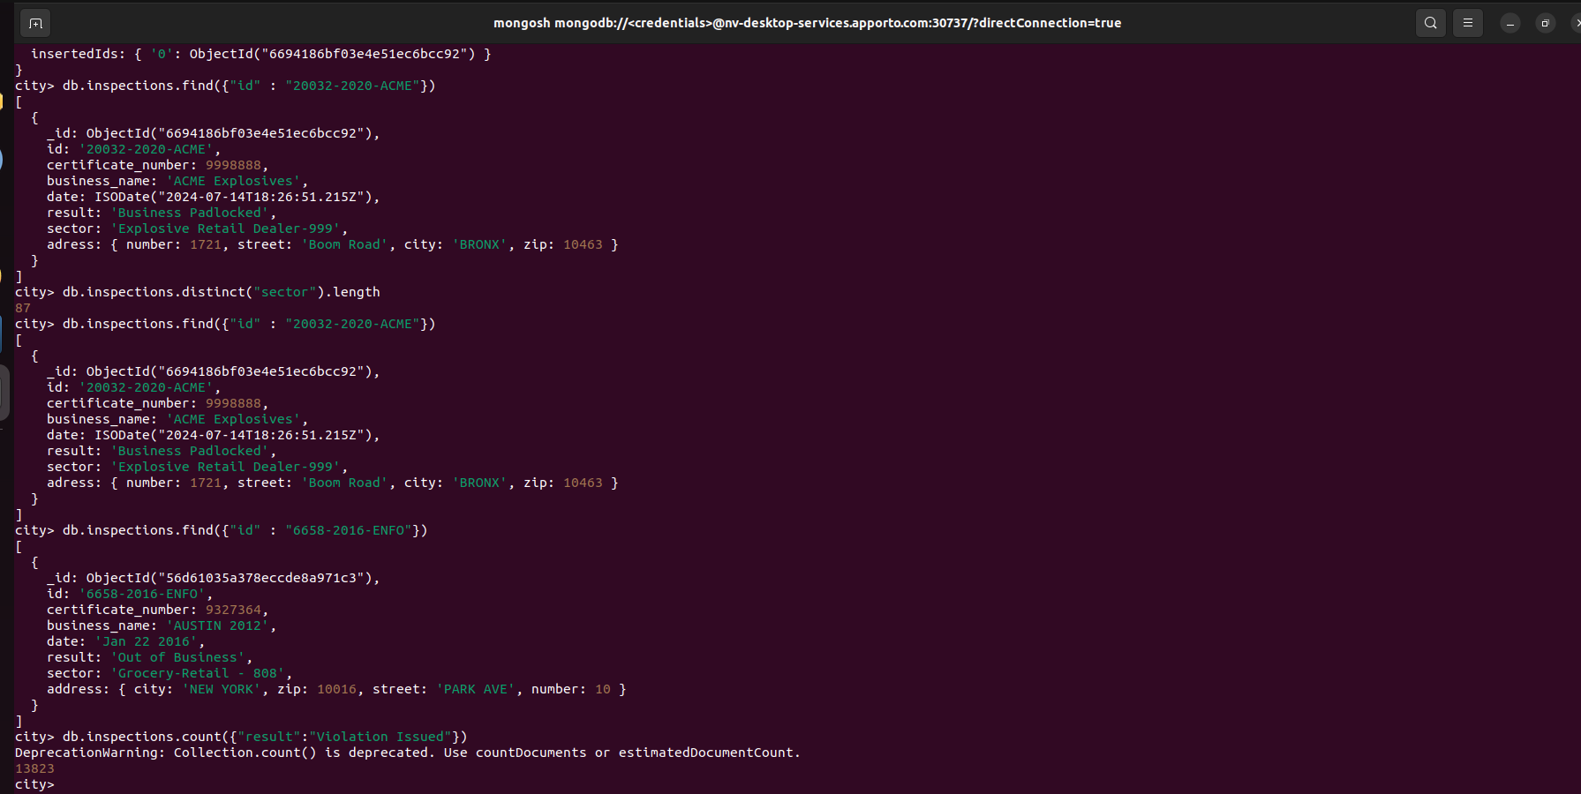

How many businesses have a “Violation Issued”?

13823

1. Using the appropriate command in the mongo shell, **update the document** with the ID “20032-2020-ACME” in the collection “inspections” in the database “city” with the information below.

|  |  |
| --- | --- |
| **Key** | **Value** |
| business_name | "New ACME Flowers" |
| Result | "Business Re-opened |
| comments | "Flowers after the explosion" |

1. Verify your database update using the appropriate **find()** function in the mongo shell. Provide a **screenshot** as evidence.

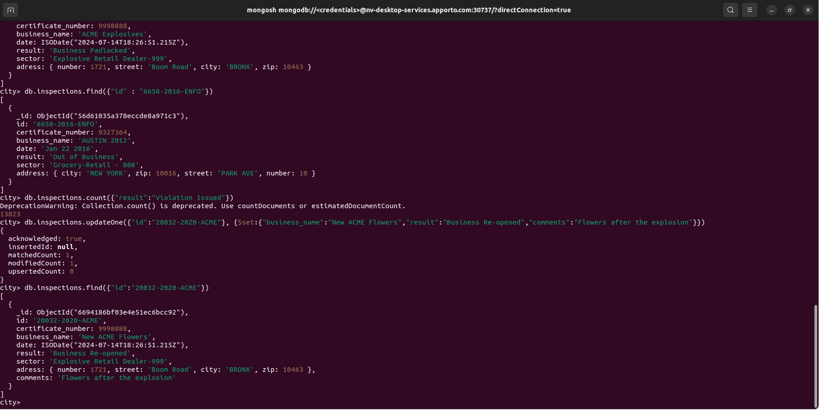

Using the database “city” with documents found in the “inspections” collection, perform the tasks listed below. Verify by providing **screenshots** of the results as evidence.

1. **Update all the documents** that contain the key-value pair "city":"ROSEDALE" in the address subdocument by changing the zip code in the address subdocument to "76114".

There are ‘0’ counts for ROSEDALE to update

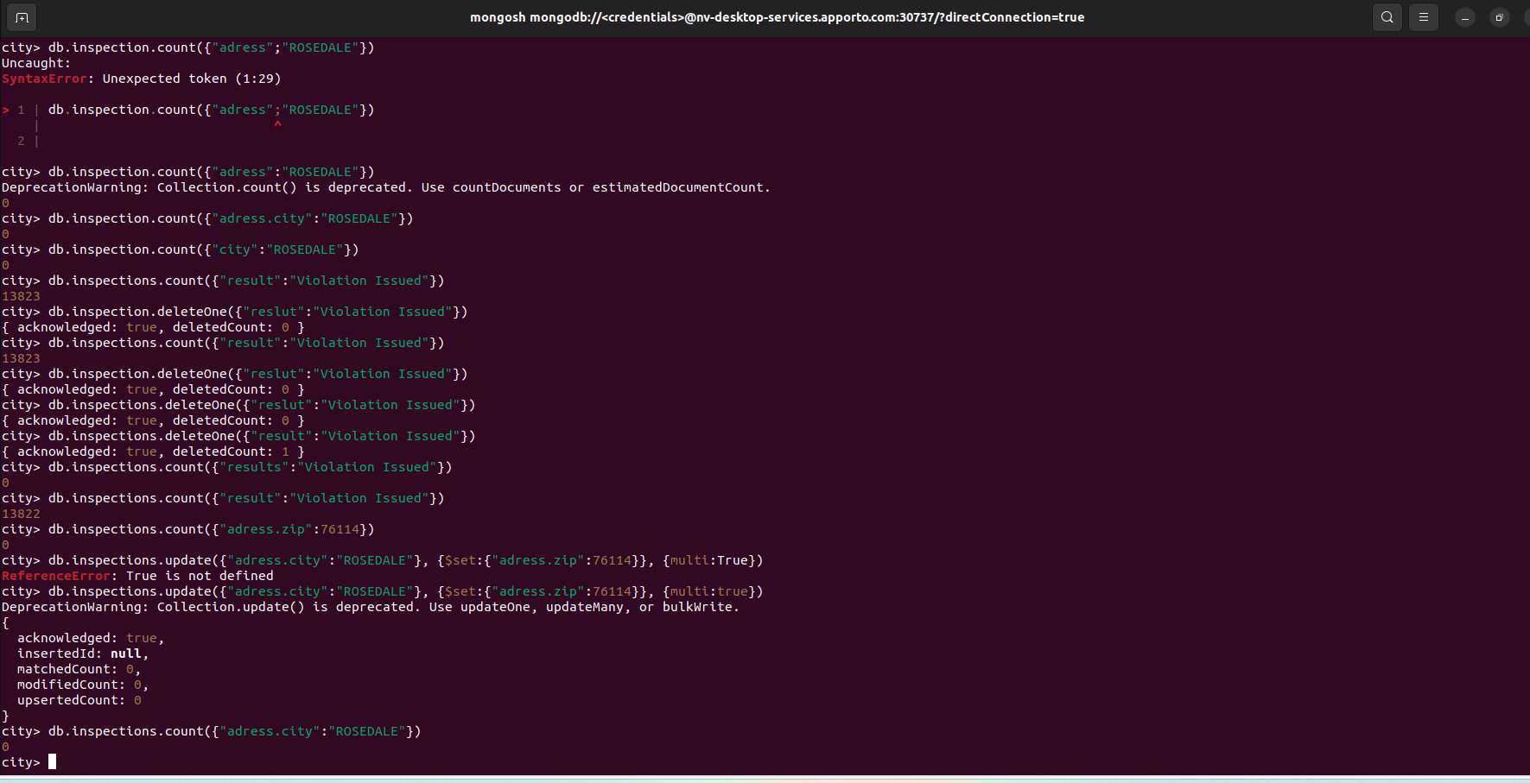

1. **Remove the first document** with the key-value pair "result":"Violation Issued."

